bitRec Technical Guide
v1.1

Table of Contents

Introduction 3
What is Recommendation System 3
Why it usefull ??? 3
Initial steps 6
Recommender System setup and preconfiguration 6
Data Upload 6
Data structures 7
Business units 9
Examples 9
Getting Recommendations 12
Sending statistics data 14
Reviewing statistics data 16

Introduction
This technical guide will help to integrate our recommendation system to your e-shop platform. All steps will be separated by different topics. Examples will be provided for several programming languages.
Each topic will start from short introduction and will go deeper afterwards. The topics are arranged in the way as our recommendation system works – in that way it will be more easier to understand why some functionality is needed and how to use it properly.

What is Recommendation System

Why it usefull ???
There is several ways to improve e-shops' sold items quantity and one of them is recommendation system. Well recommended items improve customers' impulsive purchases (in addition to planned items, also bought items that customer didn't planned to buy). Recommended items not only increase impulsive purchases, but also helps customers to discover new items as well. Some of those newly discovered items, customer will start to buy regularly.
But how recommendation system helps to achieve this? To answer this, lets look at several examples. Lets imagine three types of Items' description page – without recommendations, with random guessed items, with recommendations:

In order to stimulate customers' impulsive purchase we need to “introduce” him items that he would be willing to buy, and common place for those “introductions” are in items main/description pages, because customers always goes to those pages.
Now, if there is no items, as recommended ones, displayed – there won't be even a tiny impulsive purchase simulation. If recommended items are selected using random guess method – the stimulation will be a small one. And if the items are recommended using good recommendation algorithm impulsive purchase simulation is increased drastically.
It's important to understand, that customer won't select items that he or she is not interested in it. And if the item is from customers' interest list – still there is only a probability, that the item will be selected (but it's much better than nothing).
In order to show what impact it makes, lets make a simple example. Lets assume that:
- we provide 4 recommendations.
- there is 0% chance that item from customers' non interest list will be selected (won't be selected at all).
- there is 20% chance that item from customers' interest list will be selected (1 of 5 times it will be selected).
- there is 10% chance that item, selected by random, will be from customers' interest list.
Example 1 – Items are provided as randomly chosen:
If items are chosen randomly, there is 40% chance in overall, that between those 4 items, there will be one item from customers' interest list (while each recommendation has 10%, we need to sum those chances to get overall probability). But even in those cases, when in 4 of 10 times there is a good item, this good item has 20 chance that it will be selected:

So in this case there is only 8%, that one of the recommended items will be selected. While there is cases, that 2, 3 and even all 4 good items will appear, but those chances are quite tiny ones and in overall there is about 10% that items from recommendations list will be selected.

Example 2 – items are chosen from calculations using customers' historical data:
In this case all items will be from customers' interest list, while there was executed calculations using historical data, and now recommendation system “knows” what customer likes:

In this case there is 80% (20%+20%+20%+20%) chance that item from recommendations list will be selected by customer.

Please note, that in real life those probabilities are quite different and it depends on many factors. Those examples are just for information purpose, in order to get familiar why it is important to use historical data for recommendation calculations, and how it can affect the success that recommendation would be selected by customer.

Initial steps

Recommender System setup and preconfiguration
This step is done by our, bitRec, side. We will allocate required resources, install all required software and configure and prepare it for you. When this step will be completed you will be provided with:
- Recommendation System URL address – by this address, you'll be able to access REST services.
- User name and Password – for security reasons, communication is made on HTTPS channel and all functions are secured by user name and password

Data Upload
For first time it's possible to upload historical data providing us database dump, or other format file. Just before this step, our both sides should agree on that format. In this case, initial data upload might be quite shorter (it depends on how much data needs to be uploaded).
But it's not necessary to make initial data upload using agreed custom methods. It might be done through standard REST API for data upload.
All REST functions for data upload are documented in our REST API documentation.
The order for calling functions is not strict one, but it's recommended to upload Carts data at first, and after then – upload items, customers, business units data.
Data upload is continuous process, because it is needed to upload data changes at defined time interval. Just after initial data upload, each time there will be needed to upload such data, that was changed or newly created from last data upload:
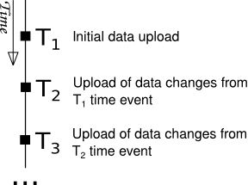

Data structures
In this section it will be shown all data structures, that are used with REST functions.
Item
fields:
- externalItemId – Item ID in your system. String value.
- price – Items price. Float value.
- category1id – if exists, ID of I category. String value.
- category2id – if exists, ID of II category. String value.
- name – Items name. String value.
- description – items description. String value.

Customer
fields:
- externalCustomerId – Customer ID in your system. String value.
- gender – Customers' gender. String value. Valid values are: 'M' – for males, 'F' – for females.
- birth – Birth date of customer. Date value. If you are constructing JSON object as string, then the format is 'yyyy-MM-dd' (e.g. '1975-05-16').

Upload Cart
fields:
- externalCustomerId – customer's ID in your system. String value.
- ExternalBusinessUnitID – ID of business unit, to which this cart depends. String value
- orderTimestamp – Date and Time of the carts purchase. Timestamp value. If you are constructing JSON object as string, then the format is 'yyyy-MM-ddTHH.mm.ss.ms' (e.g. '2012-05-16T15:32:12.000')
- externalItems – List of Upload Cart Item data structures.

Upload Cart Item
fields:
- externalItemId – Items ID in your system. String value.
- Price – price of the item. Float value.

UploadBusinessUnitItem
fields:
- externalItemId – Item ID in your system. String value.
- ExternalBusinessUnitId – ID of business unit. String value.
- active – flag to indicate if current item in this business unit is active or not. Boolean value.

UploadItemAssociation
fields:
- externalItemId – Item ID in your system. String value.
- AssocItemId – associated Items ID in your system. String Value.

Cart
fields:
- externalCustomerId – Customer ID in your system. String value.
- OrderTimeStamp – date and time of this order (when cart was purchuased). Timestamp value.
- ExternalItemIds – List of Item IDs in this cart. List of strings.

Business units
Let's say you have online shop which is operating in more than one region and each region has it's own restrictions on what items you can sell. For example in region A you can sell items L, M and N, but can't sell item G, while in region B you can sell items L, N and G, but can't sell item M. And in that situation, for region A it wouldn't be wise to recommend item G, because it is not for sale there.
For those situations comes handy our “Business Units” configuration. Business units in bitRec recommender system are described as unique or separated area where items are sold. It means that each business unit define it's own items catalog – it's like an all items filter, can enable or disable certain item.
When you upload data, items available for their business units are set by default to available, but you can disable and enable them in any moment. For this you need to use REST business units manipulation functions:
- in order to disable item in business unit
/services/businessunits/{externalBusinesUnitId}.{externalItemId}/deactivate

- in order to enable item in business unit
/services/businessunits/{externalBusinesUnitId}.{externalItemId}/activate

- batch update list of business units data
/services/businessunits

Item Associations
If, on some cases, you need that recommended items would be stricktly only from associated items (for example: If customer is viewing Pentax camera body, then all recommended items should be valid accessories for this body – it wouldn't be wise to recommend accesory that doesn't fit for current body).
The item associations helps to solve this problem. Item association is a pair of two items, that fits to each other. And if this information will be stored in our recommendation system, then it is possible to recommend only those items that fits with selected one.
If you want to save item associations - Use REST function:
/services/data_upload/item_associations

Examples

PHP code example:
$url = "<Your RecSys URL>/services/data_upload/carts";

$data = '[{"externalCustomerId" : "4587", "externalBusinessUnitId" : "Velo_shop","orderTimestamp": "2013-06-20T12:00:00.000", "externalItems": [{"externalItemId":"1154", "price":12.36}, {"externalItemId":"1155", "price":18.99}]}]';

$curl = curl_init();

curl_setopt($curl, CURLOPT_POST, 1);

curl_setopt($curl, CURLOPT_POSTFIELDS, $data);

// Optional Authentication:

curl_setopt($curl, CURLOPT_HTTPAUTH, CURLAUTH_BASIC);

curl_setopt($curl, CURLOPT_USERPWD, "<your user name>:<password>");

curl_setopt($curl, CURLOPT_HTTPHEADER, array("Content-Type: application/json"));

curl_setopt($curl, CURLOPT_URL, $url);

curl_setopt($curl, CURLOPT_RETURNTRANSFER, 1);

curl_exec($curl);
JAVA code example:
ClientFactory clientFactory = new ClientFactory("<Your RecSys URL>", "<your user name>", "<password>");

DataUploadResource dataUploadClient = clientFactory.getDatauploadServiceClient();

List<String> externalItemIds = new ArrayList<String>();

List<UploadCartItem> upCartItemList = new ArrayList<UploadCartItem>();

UploadCartItem upCartItem = new UploadCartItem();

upCartItem.setExternalItemId("1154");

upCartItem.setPrice(12.36);

upCartItemList.add(upCartItem);

upCartItem = new UploadCartItem();

upCartItem.setExternalItemId("1155");

upCartItem.setPrice(18.99);

upCartItemList.add(upCartItem);

UploadCart tempCart = new UploadCart();

tempCart.setExternalCustomerId("4587");

tempCart.setOrderTimestamp("2013-06-20 12:00:00");

tempCart.setExternalBusinessUnitId("Velo_shop");

tempCart.setExternalItems(upCartItemList);

List<UploadCart> upCartsList = new ArrayList<UploadCart>();

upCartsList.add(tempCart);

BaseClientResponse<?> response =
(BaseClientResponse<?>)dataUploadClient.uploadCarts(upCartsList);

Python code example:
import json, requests

url = "<Username>:<Password>@<Your RecSys URL>/services/data_upload/carts"
json_str = [{"externalCustomerId" : "4587", "externalBusinessUnitId" : "Velo_shop","orderTimestamp": "2013-06-20T12:00:00.000", "externalItems": [{"externalItemId":"1154", "price":12.36}, {"externalItemId":"1155", "price":18.99}]}]

headers = {'content-type': 'application/json'}
r = requests.post(url, data=json.dumps(json_str), headers=headers)
print r.status_code

Getting Recommendations
To get recommendations all you need is just call one REST service function and you'll get list of recommended item IDs. When you'll get those item IDs it's all up to you how you display those items for your customer.

PHP code example:
$url = "<Your RecSys URL>/services/recs/top.154.4.Velo_shop";

//First time our cart is empty
$data = '[]';

$curl = curl_init();

curl_setopt($curl, CURLOPT_POST, 1);

curl_setopt($curl, CURLOPT_POSTFIELDS, $data);

// Optional Authentication:

curl_setopt($curl, CURLOPT_HTTPAUTH, CURLAUTH_BASIC);

curl_setopt($curl, CURLOPT_USERPWD, "<your user name>:<password>");

curl_setopt($curl, CURLOPT_HTTPHEADER, array("Content-Type: application/json"));

curl_setopt($curl, CURLOPT_URL, $url);

curl_setopt($curl, CURLOPT_RETURNTRANSFER, 1);

echo curl_exec($curl);
JAVA code example:
ClientFactory clientFactory = new ClientFactory("<Your RecSys URL>", "<your user name>", "<password>");

PredictorResource predictorClient = clientFactory.getPredictorServiceClient();

List<String> predictorClient.getTopK(“154”, 4, “Velo_shop”, new Cart());

Python code example:
import json, requests

url = "<Username>:<Password>@<Your RecSys URL>//services/recs/top.154.4.Velo_shop"
json_str = []

headers = {'content-type': 'application/json'}
r = requests.post(url, data=json.dumps(json_str), headers=headers)
print r.status_code

Sending statistics data
Right now you can preview some statistics data of your e-shop:
- Total recommendations
- Total versus Selected recommendations
- Average cart size
- All cart items

If you want to examine all statistics data in the future, at first you need to upload some additional information – which recommended item was selected by customer. If you do this, then you could examine chart “Total versus Selected recommendations”.
To send this information, you'll need to call REST function after each time customer selects a recommendation:

PHP code example:
$url = "<Your RecSys URL>/rec_selected.2013-06-12 12:35:00.154.15266";

//First time our cart is empty
$data = '[]';

$curl = curl_init();

curl_setopt($curl, CURLOPT_POST, 1);

curl_setopt($curl, CURLOPT_POSTFIELDS, $data);

// Optional Authentication:

curl_setopt($curl, CURLOPT_HTTPAUTH, CURLAUTH_BASIC);

curl_setopt($curl, CURLOPT_USERPWD, "<your user name>:<password>");

curl_setopt($curl, CURLOPT_HTTPHEADER, array("Content-Type: application/json"));

curl_setopt($curl, CURLOPT_URL, $url);

curl_setopt($curl, CURLOPT_RETURNTRANSFER, 1);

curl_exec($curl);
JAVA code example:
ClientFactory clientFactory = new ClientFactory("<Your RecSys URL>", "<your user name>", "<password>");

private StatisticsResource statisticsClient = clientFactory.getStatisticsSericeClient();

Timestamp time = getCurrentTimeStamp();

statisticsClient.insertRecomendationSelected(timestamp, "154", "15266")

Python code example:
import json, requests

url = "<Username>:<Password>@<Your RecSys URL>/rec_selected.2013-06-12 12:35:00.154.15266"
json_str = []

headers = {'content-type': 'application/json'}
r = requests.post(url, data=json.dumps(json_str), headers=headers)
print r.status_code

Reviewing statistics data
You can review statistics charts every moment, you just need to visit recommender system's dashboard sites' statistics section.
All charts have from start to end date and time filter, and each chart bars' time period (hourly, daily and monthly)

All recommendations load
In this chart you'll see how many recommendations were loaded on each time frame.
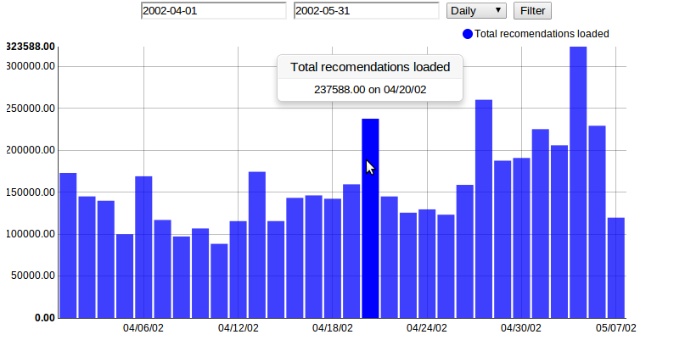

Total versus Selected recommendations
This chart shows how many recommendations were shown to customes and how many of them were selected. The full bar height represents the total recommendations laod, and the upper green bar part represents – how many recommendations were selected on that period.
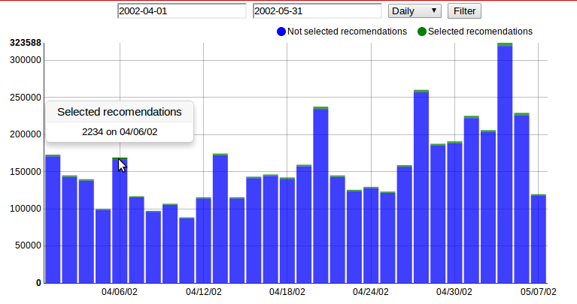
Average cart size
This chart shows the average cart size – how many items were in purshuased cart.
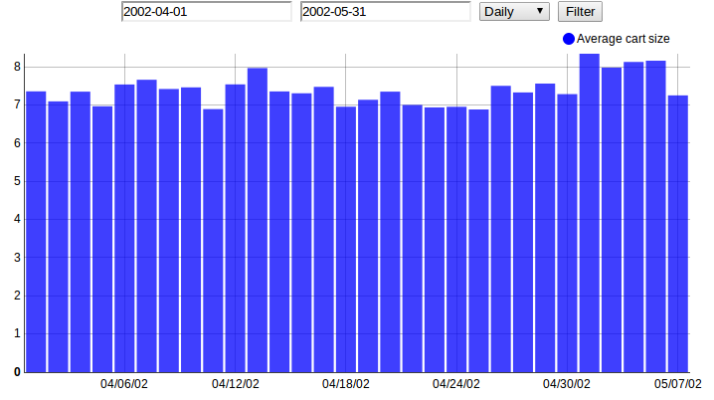
All cart items
This chart shows how many items were purshuased by customers on particular time period.
